**Locker Rental Set up**

Locker rental set up and configuration is located under the administration tab>facility settings>locker rooms. Having locker rentals set up is a good way to keep track of the lockers in your facility. It allows you to know what lockers are available and when, as well as keep track of customers using a locker.

You’ll first need to click “add new”. Then you’ll see a few fields that need to be filled out. 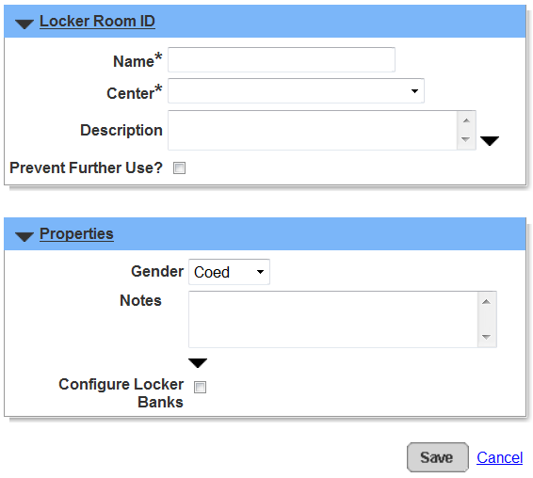

These fields are pretty self-explanatory. Fill out the all the fields with the necessary information. You can either configure the locker banks now or later if you choose to do it later, click save.

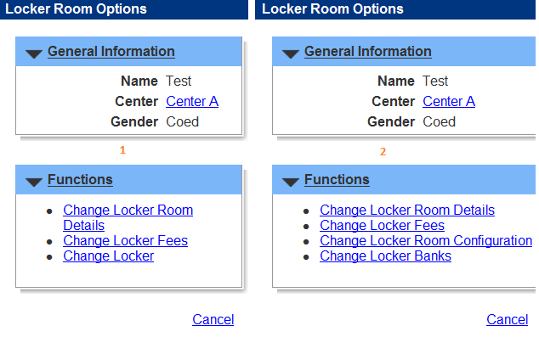

After clicking save you’ll be prompted with 3 different options for your new locker (as shown in picture 1 on left). Change locker room details will allow you to the same fields as when you were initially creating the locker. This is also were you can configure the locker banks if needed. Once you check the box “configure locker bank” you’ll have 4 options (as shown above on picture 2, on the right)

The next step after enabling the option to configure locker banks is to set up the locker fees. If you click on change locker fees>add new, you’ll notice there is not a charge in the “charge name” dropdown for the locker rooms. You’ll need to add the charge by going to administration>facility settings>charges>add new>fill out the fields, make sure the default prefill condition is set to “per day”>save. Now you’ll go back to the locker set up>change locker fees>add new>select the new charge you created from the charge name drop down menu. Once you have selected the correct charge, the fee information will automatically be added. Make any needed changes then save. You now have a fee set up for your lockers.

Next we want to configure the locker bank (if you’re using this feature) The locker bank function is beneficial if you have multiple lockers, such as a locker room. If you only have a few lockers you can use the change locker function instead.

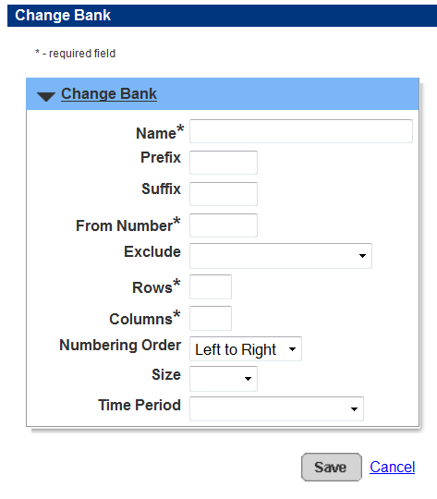

Begin by clicking change locker banks>add new, which should look like the picture above. Fill in the fields as needed. Having a visual understanding of the locker setup will help with this step. Use the duration that best fits your customer’s needs. You can also set up different configurations (daily, weekly, monthly) You’ll want to make sure the fee duration is similar to that of the locker rental duration.

Once you have saved your settings, go back to the locker details and click on change locker room configuration. You’ll see the locker bank you created in the previous step. All you’ll need to do is click the box (under non-defined bank) and drag it to the center gray box, then save. You are now done with the locker set up.

**Renting a locker** can be done in two ways, both through the front desk.

1. Reserved locker. You’ll need to find a customer and change and of the dates as needed. Once you have selected the time periods and period>click check availability>then select a locker>reserve. On the next screen you’ll need to click on the charge name>make sure the charge matches the time period amount>submit> pay>choose the payer>select the method of payment>pay and finish.
2. The other way is very similar, but it is located under reserve>availability –locker. Change the time periods as needed>click view on the locker bank>book a locker you want>select a customer> make sure the charge matches the time period amount >submit >pay>choose the payer>select the method of payment>Pay and finish.

This method allows a better picture of the locker bank availability. At a glance you how multiple options to see what lockers are booked or not booked on a given date, making it very easy to know the status of availability, as seen below.

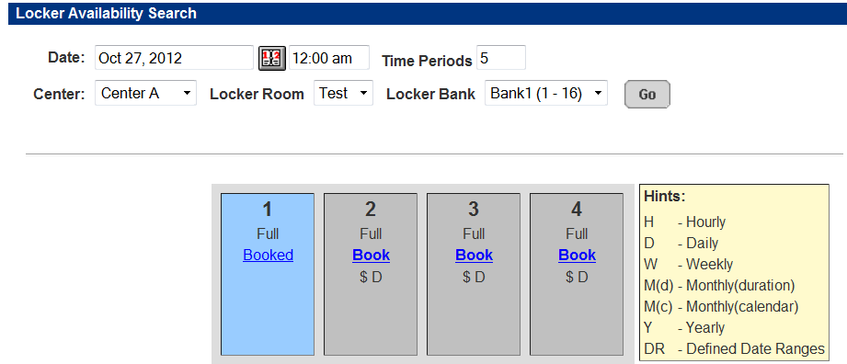

** As a note: You may want to make sure the time period amount matches the quantity. For example: if the time period is set to 3 (3 days), the quantity needs to be 3. Otherwise the locker will be rented for 3 days and only be charged for 1 day. Or Rented for 1 day, but charged for 3. This is especially important if you are setting your locker rental duration to other time periods than daily, such as monthly (duration)

**Locker Options**

**Adding locker sizes**

If you have multiple sizes of lockers, you can also implement this into your configuration. All you need to do is go to admin>facility settings>locker sizes>add new>enter a description (such as small or large)>save. This will allow you to further organize you lockers as well as distinguish prices for different sized locker rentals. (The size can be added under the locker fee)

**Refunding a locker:**

You can refund a locker by using the refund transaction function on the front desk. Click refund transaction>search for a customer>click the locker rental you want to refund>change the amount if needed, otherwise click refund and finish>select the customer>pick method of refund.

**Reporting on locker rental**

There is one main report dedicated to lockers: reports>reservation reports>lockers. This report will show you the locker room, individual locker, size, when it is rented, and to whom. It is a great way to keep track of locker usage.

**Adding locks to lockers**

ActiveNet also allows you to keep track of locks assigned to each locker. Once the lock has been entered into the system (admin>facility settings>combination locks>add new>enter information>save) that specific lock can be assigned to a locker.

In order to assign a specific lock to a specific locker: you’ll first need to pull up the locker room details (admin>facility settings>locker rooms>choose the locker room>change locker banks>click locker numbers>choose which individual locker you want to assign a lock to>search for a lock by clicking the binocular symbol>add needed lock. It should prefill the serial number and the combination>save.

You can also assign a lock to a locker at the time of the sale. You’ll also click on the binocular symbol to search for the lock as seen in the picture below. 